# Appendix XX – Design and Manufacture of the ‘Flynn Restrictor Valve’

## Working Principles

This appendix details the design and manufacture of the ‘Flynn Restrictor Valve’ (FRV, hereafter). The FRV comprises two components, the barrel and the plunger (Figure 1). The plunger fits inside the barrel and can slide to different discrete positions in order to change the resistance to the flow.

|  |  |
| --- | --- |
|  |  |
|  |  |
| 1. Barrel | 1. Plunger |

Figure : Schematics of the barrel and plunger components from the FRV, showing front and bottom views

Figure 2 shows the plunger in half-section view. The key design features are given in the accompanying labels on the diagram. Similarly, Figure 3 shows the barrel in half-section and identifies its key design features.

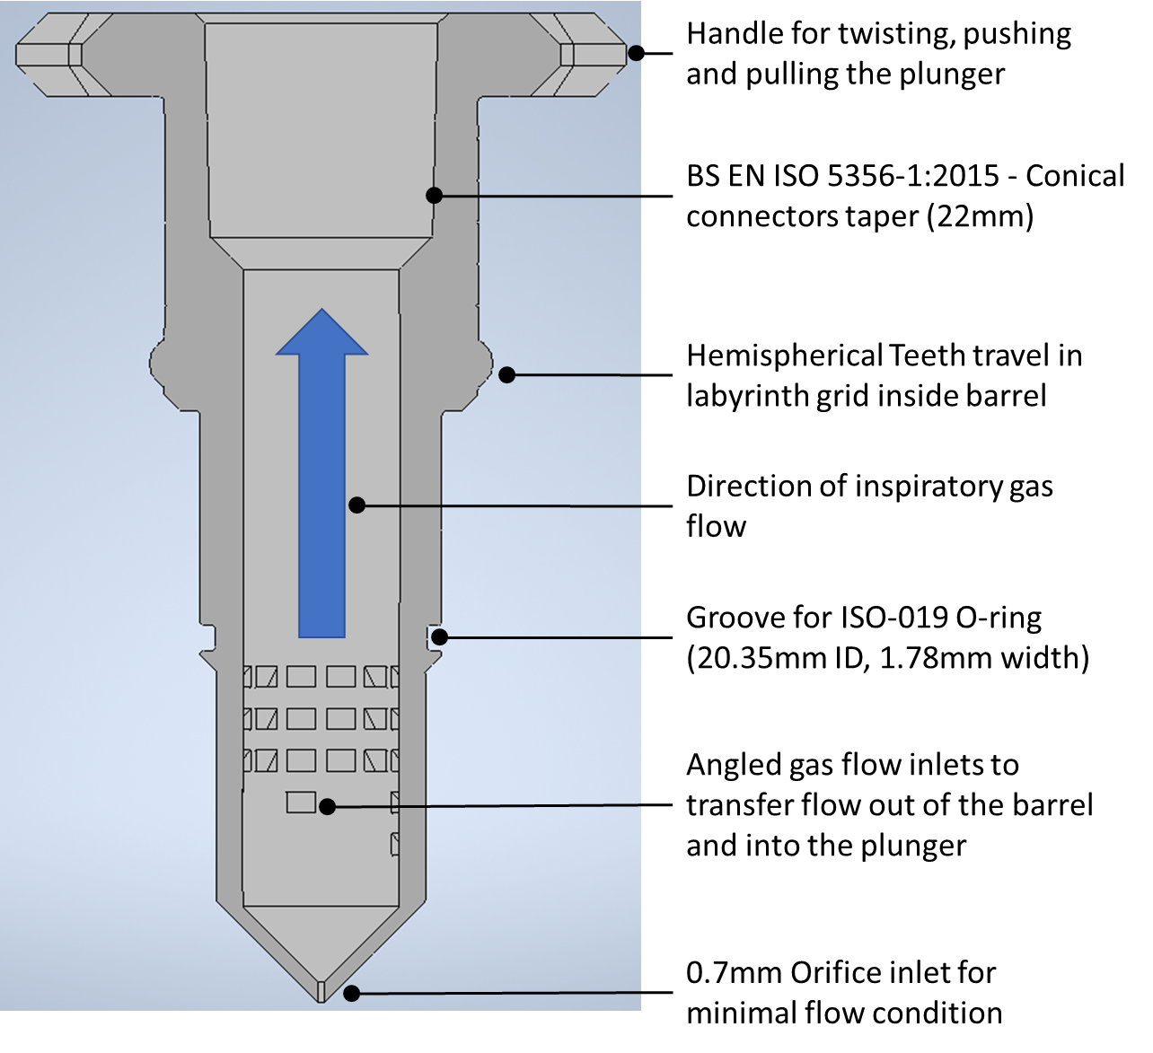

Figure : Half-section view of the plunger component, showing all of the key design features

The two-part FRV assembly is shown in half-section in Figure 4. The arrows illustrate the inspiratory gas flow paths through the orifice at the tip of the conical surface and also through the perimeter gas flow inlets. When the plunger is fully inserted into the barrel, the FRV is ‘fully open’ offering the lowest level of resistance. Conversely, Figure 5 shows the FRV in the ‘closed’ position, which limits gas flow to the orifice at the end of the conical surface. There are four intermediate settings between ‘fully open’ and ‘closed’, which gives a total of six resistance settings. The nature of these settings is given in Table 1. Each setting reveals fewer (or more) of the perimeter gas flow inlets. These inlets are angled at 45° to the main flow to aid flow out of the barrel and into the plunger. Each perimeter inlet is approximately rectangular in cross-section, with minimum cross-section 2.9mm x 2mm. The written markings on the plunger give a visual representation of how many rows of inlets are exposed in the current setting.

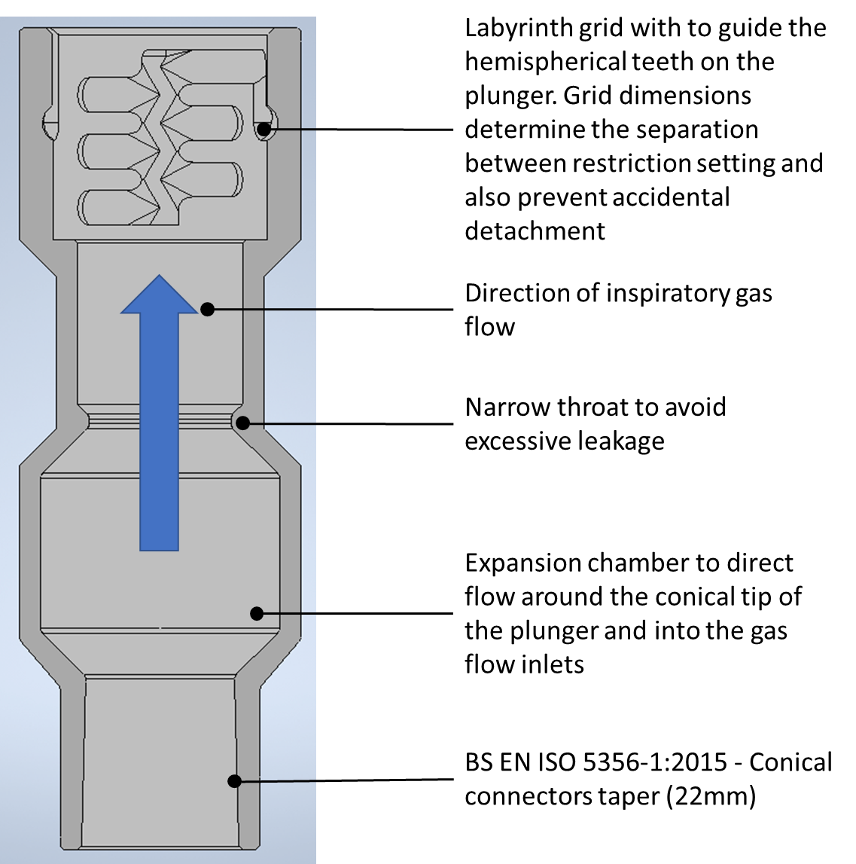

Figure : Half-section view of the plunger component, showing all of the key design features

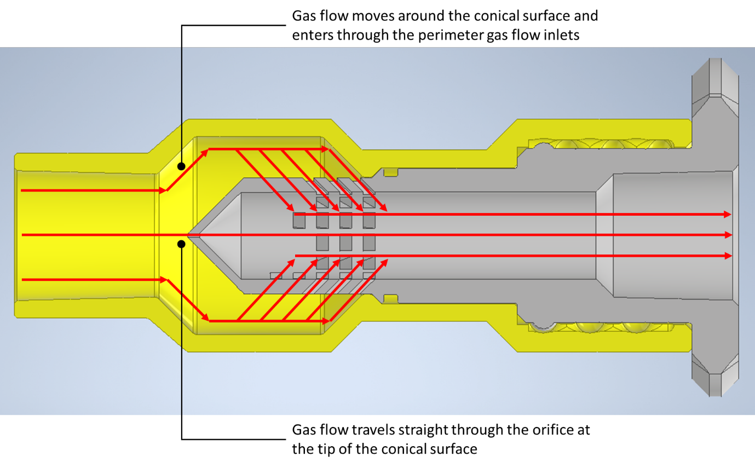

Figure 4: Half-section view of the FRV, showing the different gas flow paths in the ‘fully-open’ configuration

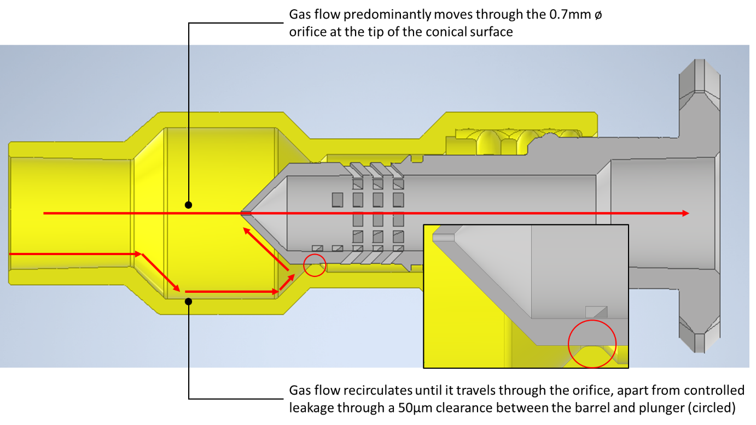

Figure : Half-section view of the FRV, showing the different gas flow paths in the ‘closed’ configuration

Table : Outline of the different FRV resistance settings

|  |  |  |  |
| --- | --- | --- | --- |
| FRV Setting | Orifice Flow? | Leakage Flow Through 50μm Clearance? | No. Exposed Perimeter Gas Flow Inlets |
| Closed | ✓ | ✓ | 0 |
| 1 | ✓ | ✓ | 2 |
| 2 | ✓ | ✓ | 2 + 4 = 6 |
| 3 | ✓ | ✓ | 2 + 4 + 12 = 18 |
| 4 | ✓ | ✓ | 2 + 4 + 12 + 12 = 30 |
| Fully Open | ✓ | 🗶 | 2 + 4 + 12 + 12 + 12 = 42 |

## Safety Features and Usability

There are two safety features in the present FRV design. The first of these is the orifice flow path and second is the presence of a leakage path. These features prevent complete shut-off of the valve, meaning that there will always be inspiratory flow available to the patient if the two parts are connected. The 2nd feature is a fool-proofing device to avoid accidental separation of the plunger from the barrel, resulting in a disconnected circuit. Figure 6 shows a U-shaped entryway that the hemispherical teeth must follow for assembly and disassembly of the two parts (red arrows). It also shows the groove used to change settings by pushing the plunger further into the barrel (dark blue arrow). Finally, it shows lateral grooves that allow the user to lock the restrictor at a given setting, much like a gear stick in a manual automotive transmission (dashed light blue arrows).

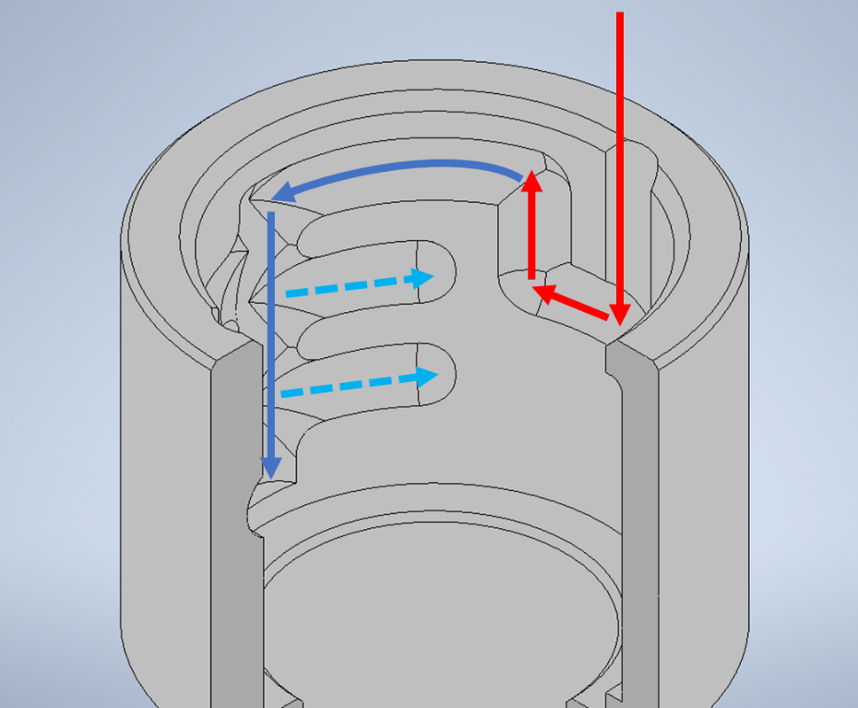

Figure : The labyrinth grid used to avoid accidental separation of the plunger and barrel (red arrows), axial adjustment to expose more or fewer gas flow inlets (dark blue solid arrows), and locking grooves to fix a chosen setting (light blue, dashed arrows – only two of the five settings are visible here)

## Design for Manufacture and Production Stages

The FRV has been specifically designed for additive manufacture and, specifically, resin-based SLA processes. All prototypes, to date, have been manufactured according to the specifications given in Table 2. However, we are confident that these components can be produced on other, similar machines and with different materials (ideally medical-grade resins).

Table 2: Additive manufacturing strategy for the FRV

|  |  |
| --- | --- |
| **Specification** | **Details and Description** |
| Machine | FormLabs, Form 2 |
| Material | FormLabs ‘Tough’ resin |
| Layer height | 100μm |
| Print time (single unit) | ~13 hours |
| Build preparation software | FormLabs PreForm (version 3.0.2) |
| Support strategy | Initially automatically generated, then internal supports deleted manually (important). Support density is 1.50 and touch-point size is 0.7mm. |
| Post-build cleaning | Initial 5-minute hand wash in IPA, followed by default washing cycle in the Form Wash machine. |
| Post-clean curing | 60-minute curing cycle in the Form Cure machine at 60°C |
| Support removal | Manual removal with flush cutters (approximately 5 minutes) |

The intended build orientation for each part and a desirable support layout are shown in Figure 7. Attention is drawn to the fact that there is no internal support whatsoever. This removes the need to remove support from surfaces that contact the inspiratory gas flow, which preserves high-quality surfaces for cleanliness and particulate reasons. The build preparation software will raise an alert about insufficient support. However these can be ignored, as they are quite conservative.

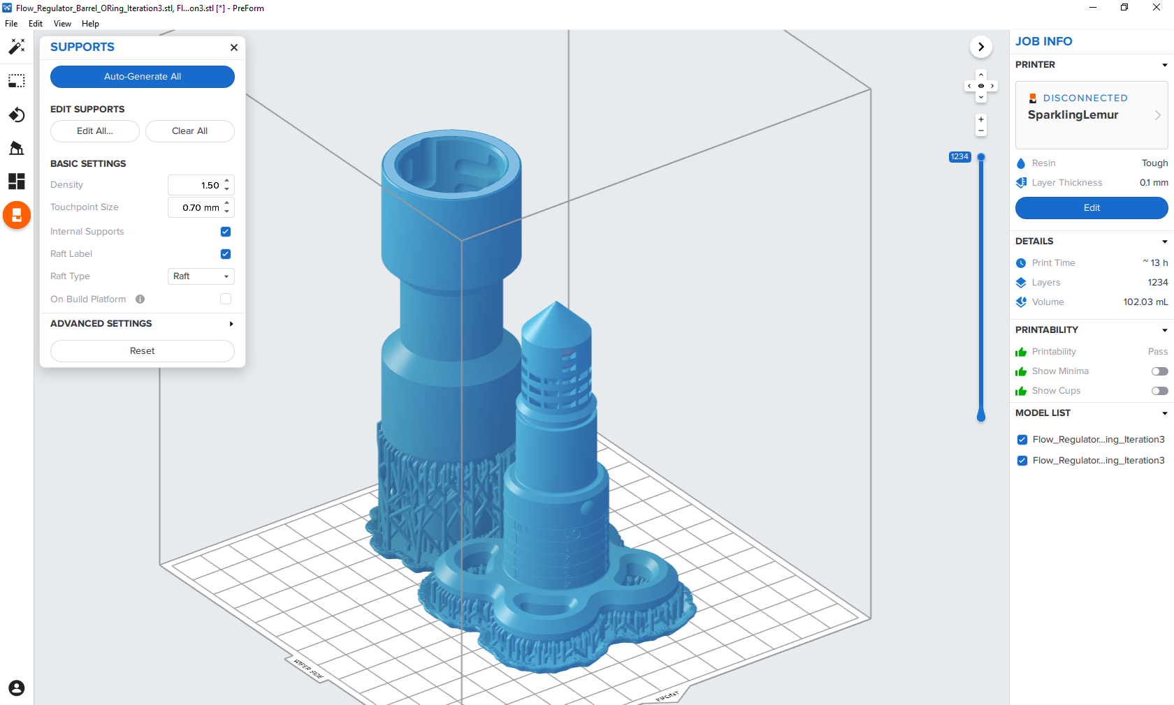

Figure :Representative build plate layout for a single FRV, showing the intended build orientation and support layout.

The time for production does not scale linearly. The print time for a single unit is ~13 hours. However, a densely packed build plate can accommodate at least three sets of the FRV with an estimated build time of 30 hours. Naturally, multiple machines can be used in unison and there are also large-format machines available.

## Cleanliness and Material Considerations

In general, the prints look to be high-quality and offer considerably fewer pores and ridges for bacteria to grow in when compared to a filament-based printing process. The components are also durable with very little chance of breaking during operation. The two-part construction (three including the O-ring) makes for straightforward and rapid disassembly. We therefore hope that these units can be sterilized rather than operating as a disposable piece. Challenges could arise with the use of ethanol as a cleaning agent, as SLA resins tend to slightly dissolve and then absorb alcohol substances. Further investigation is needed to find an appropriate resin and sterilisation method.

It is conceivable that very small amounts of polymer powder may be created as a result of rubbing between the hemispherical teeth on the plunger and the corresponding labyrinth grid in the barrel. It is therefore recommended that appropriate filters are placed between the FRV and the patient.

## Future Work

Near term future developments will focus on adjusting usability by reversing the action to ‘open’ the FRV. The resistance currently increases as the plunger is pulled further out of the barrel, which some find counterintuitive. In addition, modifications will be made to fit four FRV sets on a single build plate. Finally, testing on cleaning protocols and flowrate characteristics will be ongoing. ***The 3D model files are not yet in the public domain, but please contact Dr Joseph Flynn (***[***j.m.flynn@bath.ac.uk***](mailto:j.m.flynn@bath.ac.uk)***) for access in the meantime.***